Exercise: Single Page Application
Submit your solutions in the SoftUni judge system at:
https://alpha.judge.softuni.org/contests/single-page-applications-exercise/3468/practice
Working with Remote Data
For the solution of some of the following tasks, you will need to use an up-to-date version of the local REST service, provided in the lesson’s resources archive. You can read the documentation here.

SoftForum
This task is to write functionality for a public forum. This app doesn't need any registration. Every user is able to read and write in the forum, and by creating a post or topic, the user should write also his/her own name.
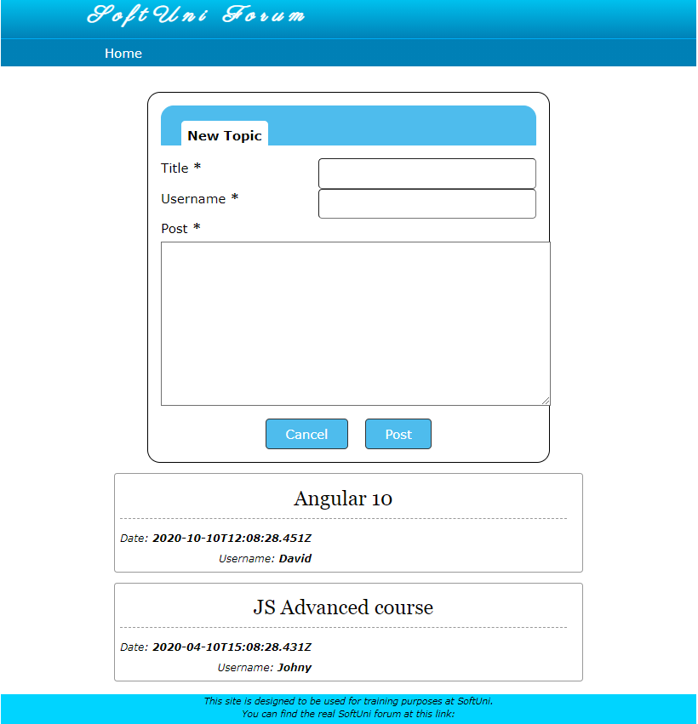

Creating topic with post
On the home page there are all topics visible. Also there is a form for creating a new topic with a title, username and post (comment) in it. The button "Post" should create the new topic if all the fields are correctly filled up (and cleans up the input fields after that). The button "Cancel" only clears all the input fields, without sending any request to the server.
Use this URL to create topics: http://localhost:3030/jsonstore/collections/myboard/posts
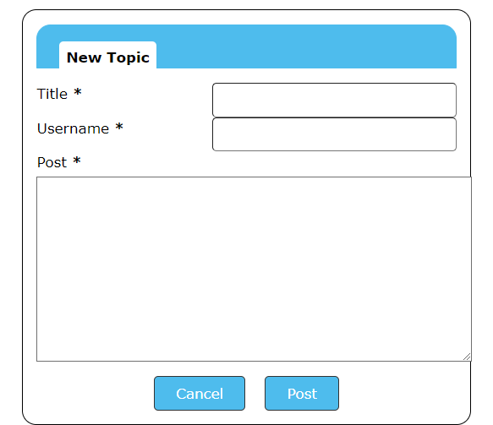

Hint:
You can add an attribute with unique id to each post when creating it.

Comment on Topic
When the user selects a topic by clicking on it, the app should redirect to a page with all posts (comments) for the selected topic and a form for creating new post (comment).
The structure for the post should be as the following:
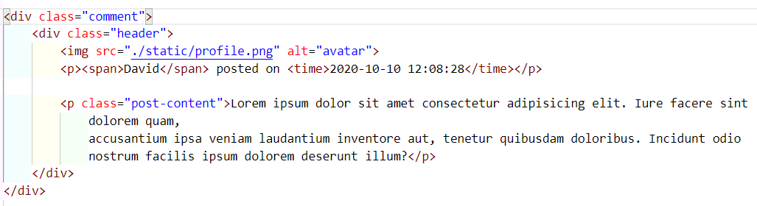
After typing in the comment and sending the POST request to the server the page should render updated view with the new post.
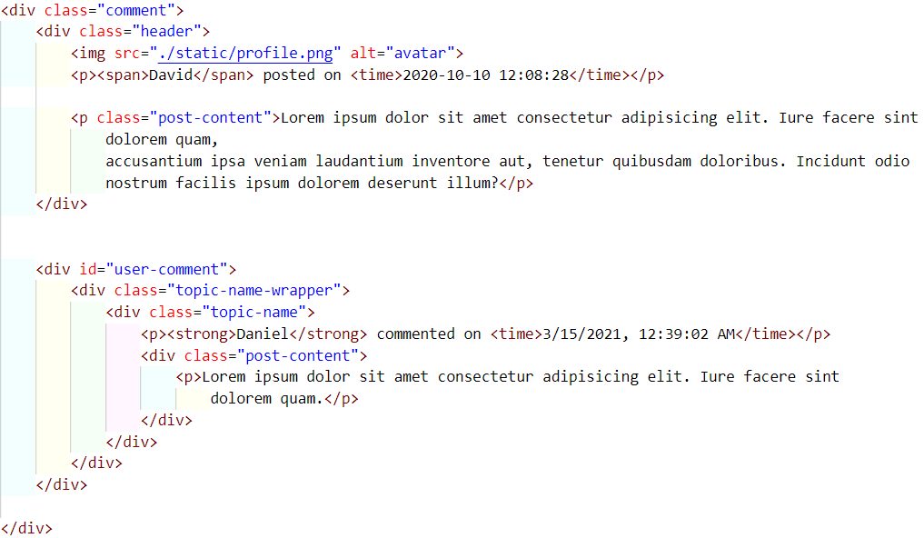
You can use this URL: http://localhost:3030/jsonstore/collections/myboard/comments
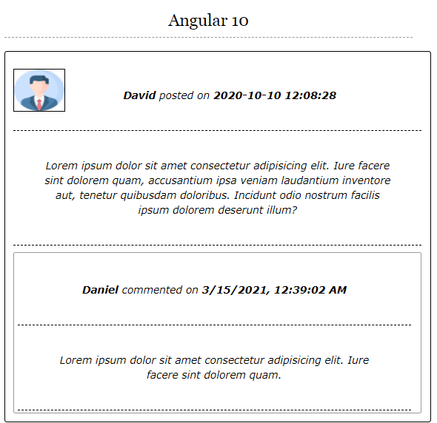
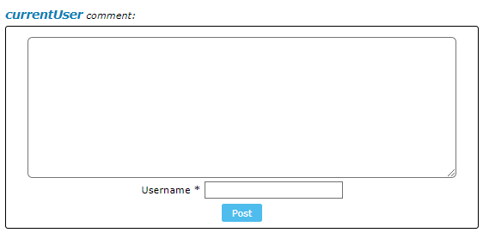

Movies – SPA
You are assigned to implement a Single Page Web Application. The app keeps users and movies. Logged-in users should be able to view add movies and like movies. Logged-in users should also be able to edit or delete the movies they have added.
REST Service
You can use the provided server to store your data. Use the following endpoints:
- Get all movies: /data/movies (GET)
- Create movie: /data/movies (POST)
- Update movie: /data/movies/:id (PUT)
- Delete movie: /data/movies/:id (DELETE)
- Get number of likes for a movie: /data/likes?where=movieId%3D%22{movieId}%22&distinct=_ownerId&count (GET)
- Get like for a movie from specific user: /data/likes?where=movieId%3D%22{movieId}%22%20and%20_ownerId%3D%22{userId}%22 (GET)
- Add a like: /data/likes (POST)
- Revoke a like: /data/likes/:id (DELETE)
Note that the provided service automatically limits the number of results from every request to 10. You may need to use pagination options, to get all entries.
HTML and CSS
You have been given the web design of the application as HTML + CSS files. Initially all views and forms are shown by the HTML. Your application may hide/show elements by CSS (display: none) or delete/reattach from and to the DOM all unneeded elements, or just display the views it needs to display.
Important: Don’t change the elements’ class names and ids. Don’t rename form fields/link/ids. You are allowed to add data attributes to any elements. You may modify href attributes of links and add action/method attributes to forms.

Navigation Bar
Navigation links should correctly change the current page (view).
- Clicking on the links in the NavBar should display the view behind the navigation link.
- Your application may hide/show elements by CSS (display: none) or delete/reattach from and to the DOM all unneeded elements, or just display the views it needs to display.
- The Logged-in user navbar should contain the following elements:[Movies] a link to the Home page, the user caption ("Welcome, {email}"), [Logout]. Each link navigates to the named page.
- The guest users navbar should contain the following elements: : [Movies] which is a link to the Home page and [Login], [Register].

Register User
By given email and password, the app should register a new user in the system.
- The following validations should be made:
  - The email input must be filled
  - The password should be at least 6 characters long
  - The repeat password should be equal to the password
- After a successful registration the app should redirect to the home page with the right navbar.
- In case of error (eg. invalid username/password), an appropriate error message should be displayed, and the user should be able to try to register again.
- Keep the user data in the browser's session or local storage.
- After a successful registration redirect to Home page.
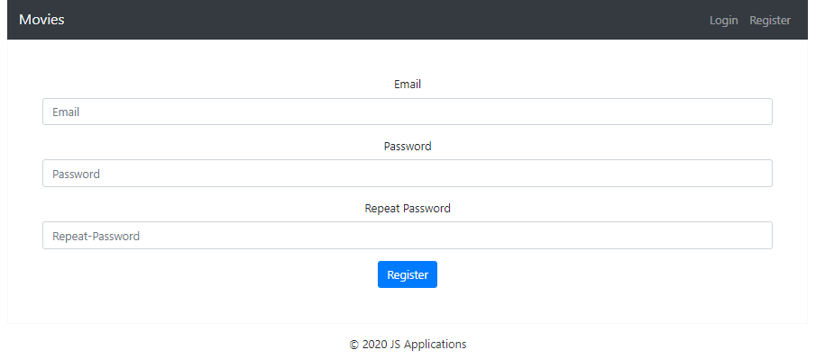

Login User
By given username and password, the app should login an existing user.
- After a successful login the user home page should be displayed.
- In case of error, an appropriate error message should be displayed and the user should be able to fill in the login form again.
- Keep the user data in the browser's session or locale storage.
- After a successful login redirect to Home page.
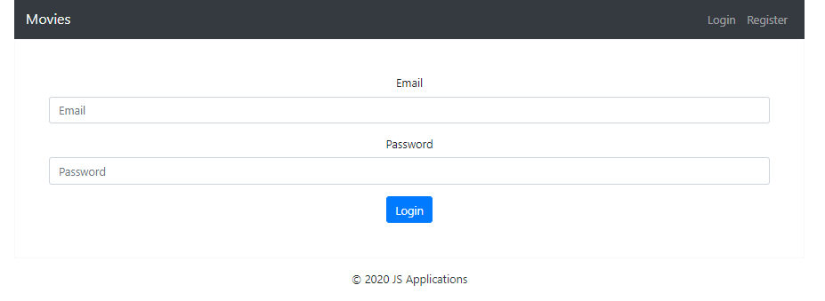

Logout
Successfully logged in users should be able to logout from the app.
- After a successful logout the anonymous screen should be shown
- The "logout" REST service at the back-end must be called at logout
- All local information in the browser (user session data) about the current user should be deleted
- After a successful logout redirect to Login page.

Home Page
Users should be welcomed by the Home page. They should be able to see all added movies:
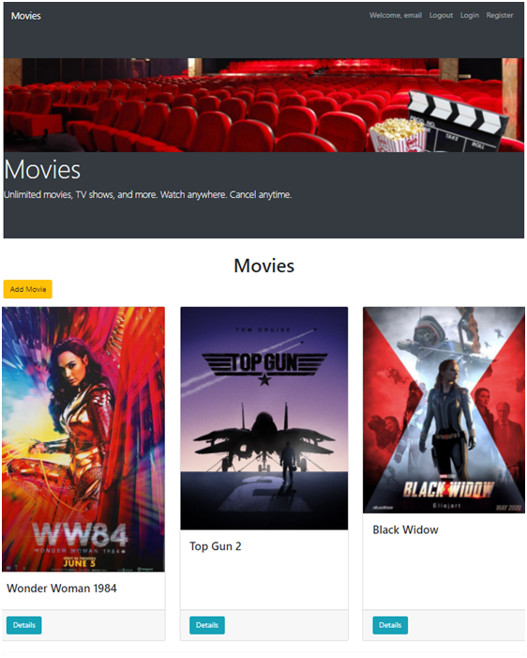
[Add Movie] button should refer to the add movie form. It should only be visible if there is a logged-in user.

Add Movie
Logged-in users should be able to add movie.
Clicking the [Add Movie] button in the Home page should display the Add Movie page.
- The form should contain the following validations:
  - The title, description and image shouldn’t be empty.
  - After a successful movie adding the Home page should be shown.
- The newly added movie should be stored in the database collection "movies".
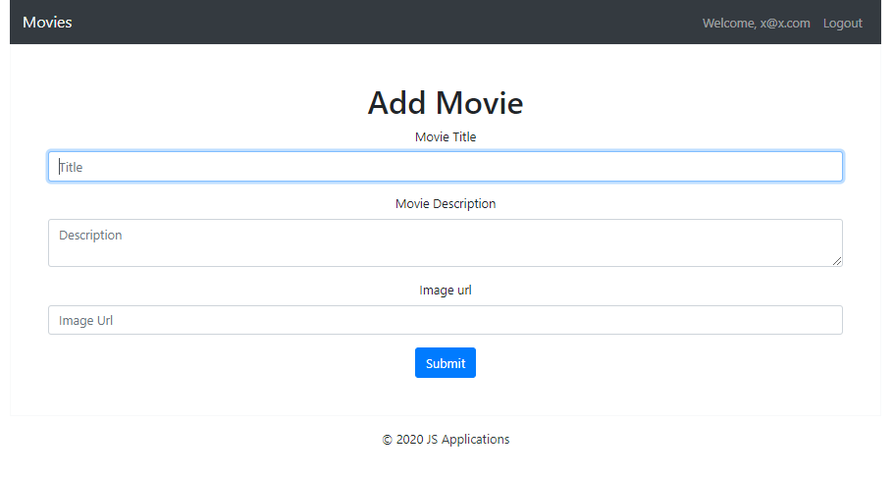
Trying to submit empty feelds should NOT be possible.

Movie Details
Logged-in users should be able to view details about movies.
Clicking the [Details] button of a particular movie should display the Movie Details page.
- If the currently logged-in user is the creator of the movie, the [Delete] and [Edit] buttons should be shown, otherwise show the [Like] button.
- When displaying the number of likes a movies has, make sure to only count each user once!
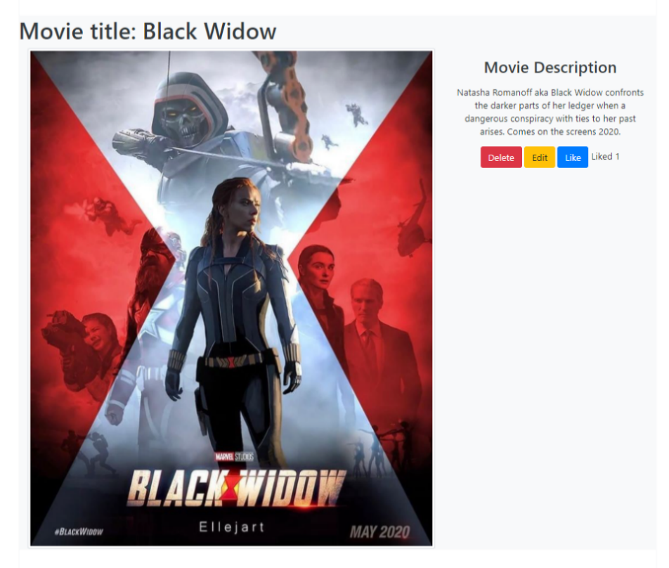
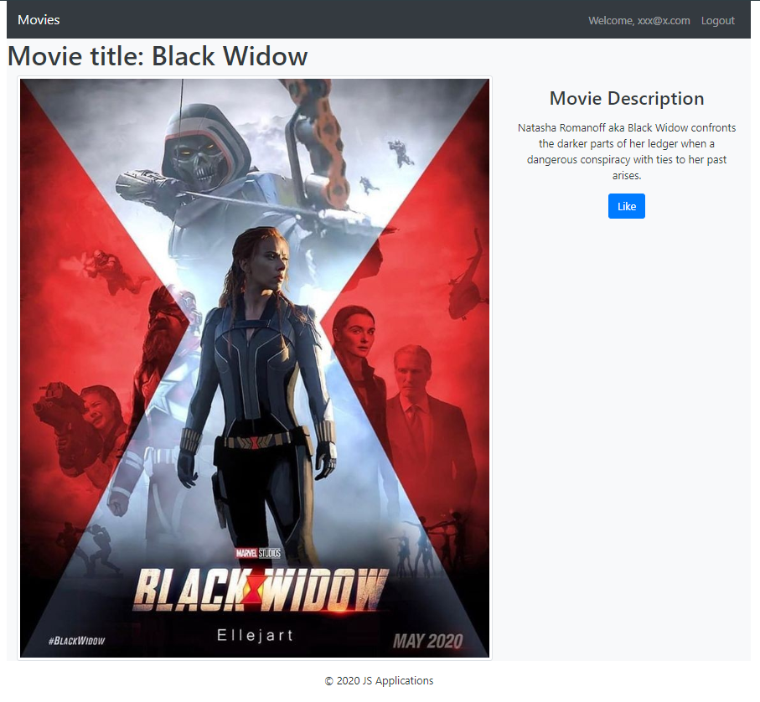

Edit Movie
Logged-in users should be able to edit movies, added by them.
Clicking the [Edit] button of a particular movie on the Movie Details page should display the Edit Movie page inserting the additional information of the movie in the input feelds:
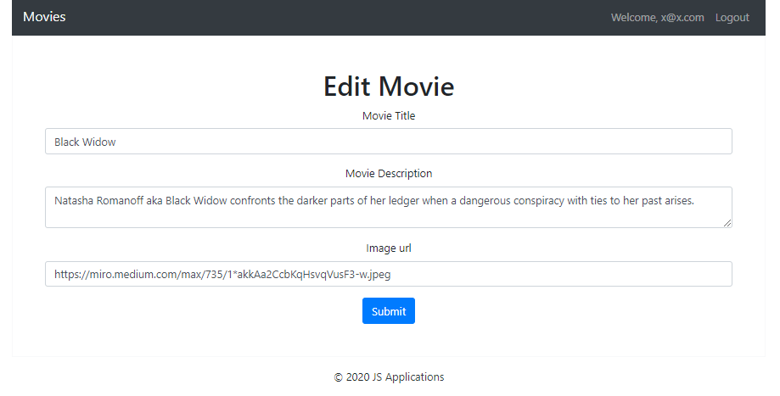
- After a successful edit the user should be redirected to the current movie Details page.

Like Movie
Logged-in users should be able to like movie, added by other user.
NOTE: A user should NOT be able to like a movie, created by himself.
Clicking the [Like] button of an movie (on the Movie Details page) should make a POST request to the following URL: http://localhost:3030/data/likes with body { movieId: id } ( id – this is the id to the current movie ) . After successfully like:
- [Like] button changes to [Liked {number of likes}] span so users can‘t like a movie multiple times.
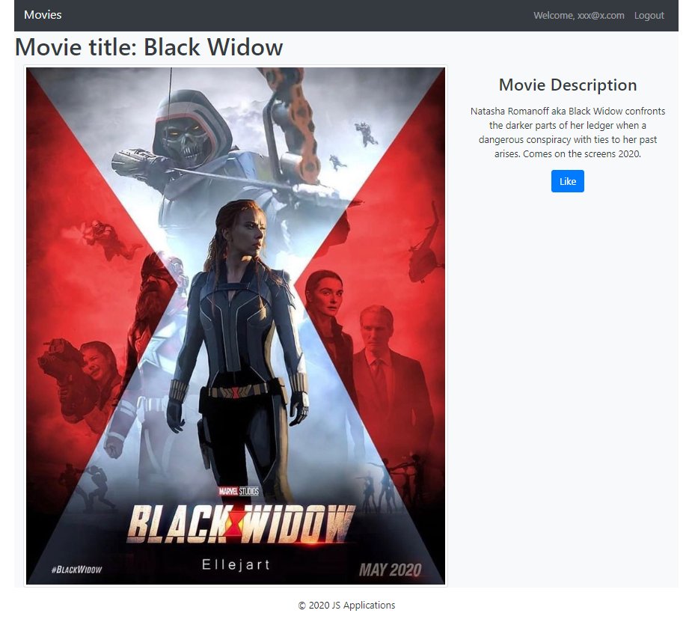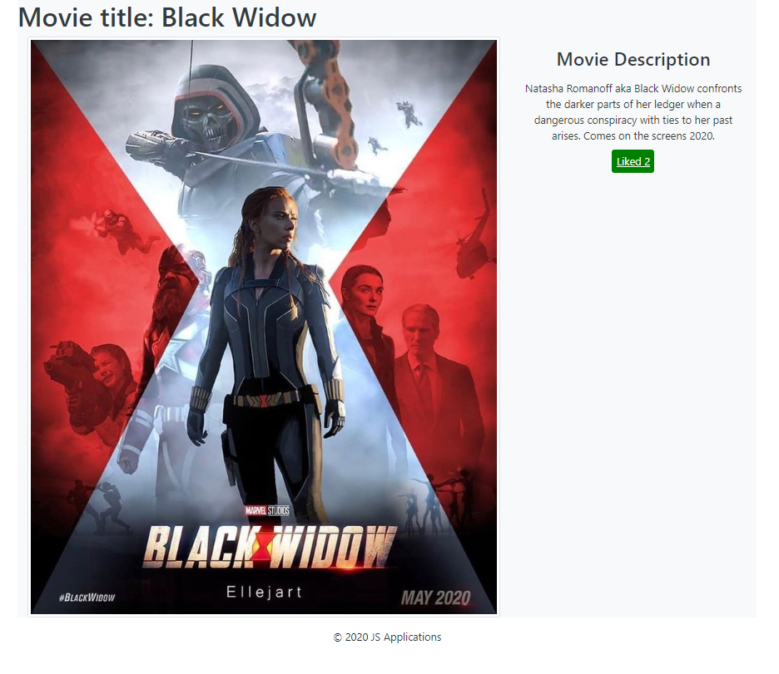

Delete Movie
Logged-in users should be able to delete their movies.
Clicking the [Delete] button of an movie (on the Movie Details page) should delete the movie.
After successful movie delete the Home page should be shown

Submitting Your Solution
Place in a ZIP file the content of the given resources including your solution. Exclude the node_modules folder if there is one. Upload the archive to Judge.
